**Geographical Information Systems**

**Assignment 1**

|  |
| --- |
| **Student Name:** Mohamed Samy Mahmoud Elgabry |
| **Student ID:** 20190441 |
| **Group No.:** S1 |

**Q1:**  This graphic represents the *Tools* toolbar. Hover your mouse pointer over each tool to see what it is named. Match the name with each tool’s icon.

|  |  |  |
| --- | --- | --- |
| A) Zoom In (by clicking once or dragging)  B) Fixed Zoom In (to the map center)  C) Pan (drag the map as you want)  D) Go Back To Previous Extent  E) Select Features (by clicking or dragging)  F) Select Elements (main cursor for using)  G) Find (feature, place, address)  H) Measure (distance and area on map)  I) HTML Popup (launch by clicking on a feature) |  | J) Zoom Out (by clicking once or dragging)  K) Fixed Zoom Out (to the map center)  L) Full Extent (zoom out to see the full map)  M) Go To Next Extent  N) Clear Selected Features  O) Identify (features by clicking)  P) Go To XY (to move around on the map)  Q) Hyperlink (allow us to access documents or web pages related to features)  R) Create Viewer Window (create a new window by dragging a rectangle) |

**Q2:** According to the Identify tool, what is the area of El Dokki and what is your location in Degrees Minutes, Seconds and in Meters?

Answer:

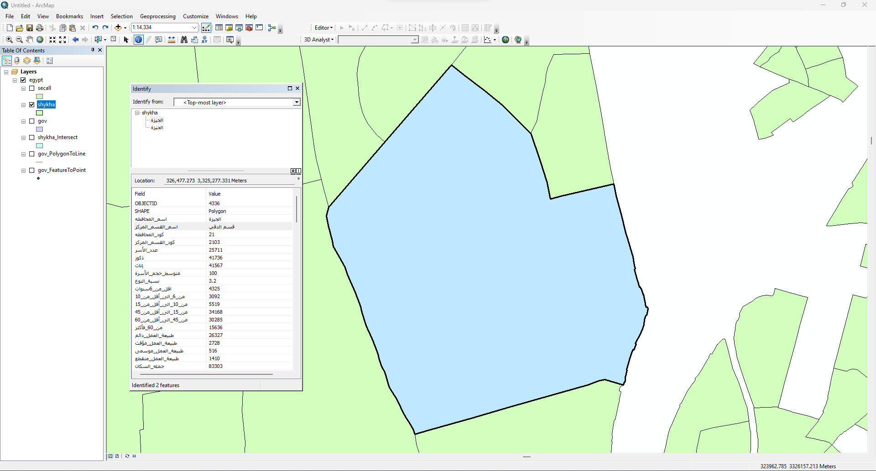

The area of El Dokki = 5092196.038717 m2

Location in Degrees Minutes, Seconds and in Meters is 326,621.392 3,324,924.620 Meters

**Q3** Using the line measurement tool, how long is Eltahrir street in Km?

Answer:

Eltahrir street length in Km = 16.719969 km

**Q4** Using the polygon measurement tool, what is the Area of “نادى الصيد” in Km square?

Answer:

The Area of “نادى الصيد” in Km square = 0.060533 Km2

**Q5** The “Shape_area” Field explains the area of each bank in eldokki. How many Banks Located in Eldokki?

Answer:

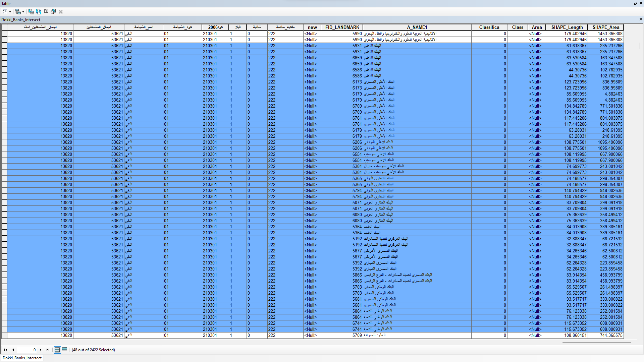

Number ofBanks located in Eldokki = 48 banks

**Q6:** Using the Select Features tool, click on some of the schools on Eldokki. Notice that selected features appear outlined in cyan. Make print screen for this selected school

Answer:

**Q7:** Select all hotels from Landmark layers where the area is >1500m square Print screen of the map with the selecting feature

Answer:

**Q8:** Export your images in JPEG format with resolution 700dpi after putting all map components (verbal scale- north arrow – legend- date of production-Inset and locator map-Neat line-projection-and cartographer)

Answer:

**Q9:** Using ArcToolbox select all schools and export it into Do_school layer convert the Do_school layer into point layer and export your map in PDF format with nominal representation

Answer:

